Name: Ahmed Mohamed

ID: 000397658

Course: Computer Training and Writing

How to use the Merge and Center feature in Excel 2013

Prof. Farhan Ahmad

How to use the Merge and Center feature in Excel 2013

The main aim of this quick guide is to help out users to Merge and Center cells on Excel 2013.

1. Open Excel 2013. The Excel sheet will open as shown in Figure 1 below.



Figure 1: Excel 2013

1. Choose any cell and type your first name and last name. (In our example we will type Ahmed Mohamed) as shown in figure 2.

Page 1



Figure 2: Excel 2013 with the name Ahmed Mohamed typed in one cell

1. Select the cell that includes the name and the cell next to it by clicking on the cell (including the name) and holding the shift key then clicking on the next cell as shown in figure 3.

Page 2



Figure 3: Excel 2013 with Ahmed Mohamed (cell) selected and the cell next to it

1. Click the Merge and Center button as shown on figure 4.

Page 3

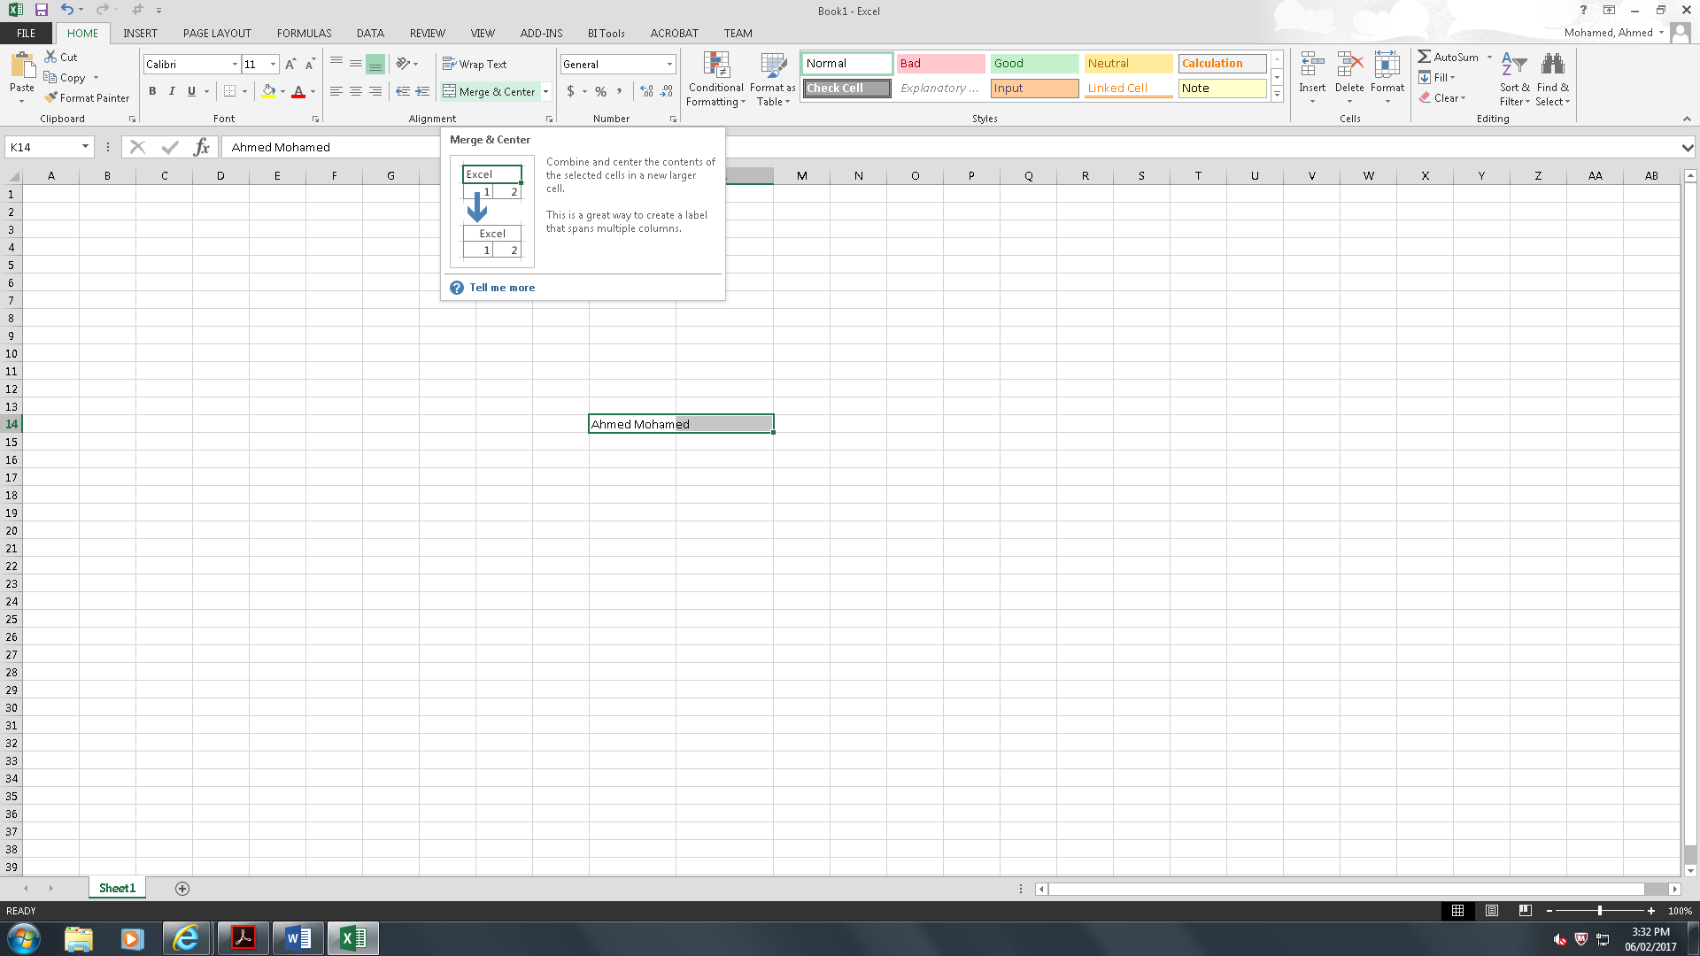

Click on the Merge and Center button

Figure 4: Merge and Center button

1. Both cells will merge together and the content of both cells will be centered in one cell as shown in figure 5

Page 4



Both cells are merged and centered into one cell

Figure 5: The two cells are merged and centered and the cell content is now in one cell

You can apply the merge and center tool to any cells in order to merge and center its content.

Page 5